PROPERTY INFORMATION
757 Starbuck Rd Aiken SC 29803
PROPERTY ADDRESS CITY STATE ZIP
DESCRIPTION OF PROPERTY
Single Family Two Family Apartments Manufactured Home
REPORTED/ESTIMATED AGE 2001

INSPECTION DETAILS
CLIENT NAME  INSPECTION DATE  05/17/2017  TIME  3:00 PM  TYPE OF INSPECTION  Standard Inspection  Structural  Mechanical  Utilities | WEATHER  Partly Cloudy  TEMPERATURE  88ºF  STATUS  Occupied  Vacant  Moving  New Construction | 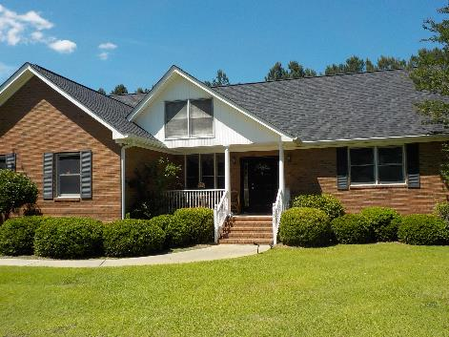

PURPOSE AND SCOPE OF INSPECTION
The purpose of this report is to render an opinion as to the major structural, mechanical, and utility elements of the referenced property on the date of the inspection. Report findings are performed according to the terms and conditions of the inspection order agreement. Evaluation/inspection is basically limited to a visual assessment, and is NOT a technical exhaustive inspection. Electrical receptacle covers may be removed and tested; the same is true with the electrical panel box; mechanical equipment will be inspected using normal controls; Code Compliance/Building Standards items that are visible will be annotated, concealed, inaccessible items that may involve codes/standards, specifically fireplace flues and inside of chimney’s if not visible, cannot be evaluated. Concealed areas are not visible, thus not evaluated; furnishings are NOT moved; storage is NOT moved. If items are in the off position, such as main water cut off, gas lines, and electrical breakers, these are NOT activated/turned on. This is a visible, non-intrusive evaluation/inspection. The purpose of this inspection is to reduce the risk involve in purchasing a property at a reasonable price.

THIS REPORT MUST BE READ COMPLETELY. Additional concerns or further evaluation requirements will be annotated on the specific pages that are not structural, mechanical or utility defects. The summary page is NOT the entire report. The following pages may include items that are of concern to you, the client. This report is intended to identify visual defects - as defined - that involve structural, mechanical and utilities.

- ACCEPTABLE (AC): This item is performing its intended function as of this date of the inspection. (Functioning.)
- NOT PRESENT (NP): This item does not exist in this structure being assessed/inspected.
- DEFECT (DE): This item is structurally unsound, unsafe or hazardous, inoperative, or otherwise requires repair.
- COSMETIC: Normal wear & tear; does not affect negatively the structural, mechanical or utility of this dwelling. Examples of cosmetics are stress settling cracks, caulking/sealing issues; stains on floor coverings, floor coverings that are torn, have tears such as vinyl flooring; doors and windows that require adjusting, door stoppers missing, wallpaper peeling, ceiling finishes peeling or flaking (such as popcorn finishes); ceiling fans that wobble (require adjusting) moldings that have separation, weather stripping that is worn, Basically items that are not defects, do not involve the structural integrity, the mechanical or utilities are considered cosmetic by GNB Inspection standards.
- NOT ASSESSED (NA): This item was not assessed because of inaccessibility or seasonal impediments, or as agreed upon.
- FURTHER EVALUATE: May require intrusive evaluation, consult with a licensed professional in this specific field.

INSPECTION SUMMARY

EXTERIOR The dwelling’s exterior consists of brick & vinyl-siding, with a front roof-covered porch, a rear screened-in porch with functional fans, and a rear stone face open patio. • Front windows have shutters. • Wood post screen fence along rear property. • Windows bordering brick siding should have been caulked between the frame and brick, which prevents moisture/air intrusion. (Cosmetic · See Photo #1) • One rear exterior floor light is damaged; hanging by wiring. (Cosmetic · See Photo #14) • Rear screened-in porch has a screen door with torn screen. • Rear wood-framed shed. • Double-car, side garage has an automatic door with sensors. Car and storage present; some areas of walls and slab not visible. (Cosmetic)

ATTIC/ROOF The roof is covered in architectural shingles, a better quality 30-year shingle. • Fascia, eaves, and soffits have coverings. • Gutters and downspouts are present. • Left side of garage doors, fascia covering has dents and slight separation. (Cosmetic · See Photo #2) • Two roof-skylights are present. • Facing rear screened-in porch, gutter on left side appears to have a nail hole. (Cosmetic) • Attic visible framing is 2x, 4x8 sheathing, and insulation is adequate. Bonus room scuttle entry is secured; no entry.

SUBSTRUCTURE The crawlspace has 2x8’, 16 on center framing, brick walls, and block piers. Insulation is adequate, but has been taken down underneath the master bath. (Cosmetic) • Vapor barrier is adequate.

INTERIOR Floors consists of carpeting, vinyl/tile, and wood products. • Rooms have painted sheetrock walls & ceilings, and moldings. • Windows are wood-framed, double-hung, double-pane. • Ceiling fans are functional. • Smoke detection is present. • Inside the master bath closet, dried water staining appears to be around light fixture; no correlation from inside attic scuttle. (Cosmetic · See Photo #10) • In the upstairs bonus room, the sheetrock ceiling has intersections/joints poorly finished. (Cosmetic) • Bathrooms consist of a left-side bedroom bath, hall bath, master bath, and upstairs bonus room half bath. Master bath whirlpool tub is functional; however, the hot water valve fixture is slightly loose. (Cosmetic · See Photo #9)

MECHANICAL The HVAC system consists of two units on the exterior right side: gas pack unit (2016), and a Ducane split system/heat pump (age not determined); and, an electric air handler/heat pack (2001) in the attic. Attic unit is its life expectancy; limited life should be expected. Presently the HVAC system is fully functional in both heating and cooling modes. This correlates with the thermostat’s operability. Air flow was satisfactory. • GE (2013) 40-gallon electric hot water tank is functional, produces hot water. • All built-in appliances — to include the stove, dishwasher, refrigerator, and sink disposal — were tested as functional, as well as mechanical ventilation. • Living room ventless gas log fireplace is functional.

ELECTRICAL Underground electrical service. • Main disconnect is on rear exterior. • Panel box is in garage, also with main disconnect. 120/240-volt, three-wire, 200-amps.

PLUMBING The plumbing system consists of PEX & PVC plastic water lines and PVC plastic drain lines (septic). Water pressure presently at 66 psi. Satisfactory water pressure range is between 40-80 psi. Presently no leaks or drainage issues were detected.

DEFECTS — The following are the defects as defined:
- Rear shed on block - roof decking along eaves have water damage & mold growth (See Photos #3-4); areas of wood fascia have damage; back room flooring has significant deflection/damage (See Photo #6); and, Skylights have evidence of water intrusion (See Photo #5). Further evaluate, repair/replace as necessary.
- Cover to the electric panel box in garage is only secured with one screw. (See Photo #8)
- Inside crawl space under the master bath, leak at drain pipe joint of whirlpool tub. Sub-flooring under master bath has water staining, surface mold, and areas of wood fungus. Further evaluate, repair/correct as necessary by a licensed plumber or general contractor. (See Photos #11-13)
- The in-ground sprinkler system has three functional zones, the control display has 8 zones; further evaluate.
- The front two garage windows have gaps along the top hat have been covered with wood trim. The wood trim has water/moisture absorption and should be replaced. The gap should be covered with cladding, vinyl, or masonry. (See Photo #15)

The following pages have further explanations if necessary, and general information. The purpose of this inspection is to identify problems and concerns,
with a specific emphasis on structural, mechanical, and utilities.
INTERIOR ELEMENTS
PRIMARY TYPE STRUCTURE
Ceilings: Wood Frame Textured Finish Popcorn Stucco Finish Paint Panel/Tile
Walls: Wood Sheet Rock Wallpaper Paint Paneling
Floors: Concrete Slab Carpets Wood Finish Vinyl/Tile
Window Type(s): Fixed Single Hung Double Hung Single Pane Double Pane
Sliders w/Combo Storms/Screens w/Double Glazing Metal/Vinyl
Awning Casement Single Glaze w/Screens w/Storms
Wood-Framed
Smoke Detectors: Not Determined Battery Hard Wired Not Present
Ceilings AC NP Cosmetic Defect See below.
Moldings AC NP Cosmetic Defect NA
Walls AC NP Cosmetic Defect NA
Floors AC NP Cosmetic Defect SEE DEFECT #1: back room flooring has significant deflection/damage.
Smoke alarms AC NP Cosmetic Defect NA
Stair rails AC NP Cosmetic Defect NA
Stairs AC NP Cosmetic Defect NA
Windows AC NP Cosmetic Defect NA
Room Doors AC NP Cosmetic Defect NA
Ceiling Fans AC NP Cosmetic Defect NA
Limitations Excess Furnishings/Storage
ELECTRIC
Service Line Underground Overhead Aluminum Copper
Main Distribution Line Breaker 120/240 Volt 200 Amps Copper
Location: Garage
Service Disconnect(s) None Multiple Single Main
Location: In Distribution Panel Exterior
GFCI In Panel At Receptacle(s) AFCI Protection in Panel None Observed
Service Entrance AC NP Cosmetic Defect NA
Svc Disconnect AC NP Cosmetic Defect NA
Distribution Panel AC NP Cosmetic Defect SEE DEFECT #2 / Panel box in garage, also with main disconnect.
AFCI Protection AC NP Cosmetic Defect NA
GFCI Protection AC NP Cosmetic Defect NA
Wiring/Conductor(s) AC NP Cosmetic Defect NA
Outlets AC NP Cosmetic Defect NA
Switches AC NP Cosmetic Defect NA
Exterior Light Fixtures AC NP Cosmetic Defect One exterior floor light damaged, hanging by wire.
Interior Light Fixtures AC NP Cosmetic Defect NA
GENERAL NOTES
Normal wear and tear items, cosmetic type items will be generalized in the summary; these items will be annotated as cosmetic on the specific pages. All accessible windows will be inspected, as well as all doors; smoke alarms will be observed and tested: Interior stress, settling cracks on walls and ceilings will be annotated as cosmetic if they are flush, or are hairline cracks; and if there’s no correlation from structural breaching and/or repairs. Window blinds and/or treatments are not evaluated/inspected, nor are floor coverings.

CEILINGS -- In master bath closet ceiling, around light fixture appears to have dried staining; no correlation from in attic scuttle. • In bonus room, poorly finished sheetrock intersections.
PLUMBING SYSTEM
Source of Water: Municipal Private Well Water Pressure: 66 psi
Water Pipes: Copper Brass Steel PVC Plastic PEX Plastic PB Plastic
Drainage Line: Cast Iron Brass PVC Plastic ABS Plastic
Water Pipes AC NP Cosmetic Defect NA
Drainage Line AC NP Cosmetic Defect SEE DEFECT #3: under master bath, leak @ drain pipe. / Septic
Water Pressure AC NP Cosmetic Defect NA
Washer Water Valves AC NP Cosmetic Defect NA
Plumbing Fixtures AC NP Cosmetic Defect NA
WATER HEATER
Make: GE Location: Age: 2013 Gallons: 40 Type: Natural Gas Electric LP Gas
Condition AC NP Cosmetic Defect NA
Ventilation AC NP Cosmetic Defect NA
Gas Sediment Pipe AC NP Cosmetic Defect NA
Electric Disconnect AC NP Cosmetic Defect NA
PRV AC NP Cosmetic Defect NA
Drip Pan AC NP Cosmetic Defect NA
KITCHEN
General Condition AC NP Cosmetic Defect NA
Cabinets AC NP Cosmetic Defect NA
Counters AC NP Cosmetic Defect NA
Dishwasher AC NP Cosmetic Defect NA
Trash Compactor AC NP Cosmetic Defect NA
Microwave AC NP Cosmetic Defect NA
Refrigerator AC NP Cosmetic Defect NA
Sink Disposal AC NP Cosmetic Defect NA
Stove/Oven AC NP Cosmetic Defect NA
Vent System AC NP Cosmetic Defect NA
Kitchen Sink AC NP Cosmetic Defect NA
Caulking Issues AC NP Cosmetic Defect NA
BATHROOMS
Description/Locations: Bath #1: Left side bedroom bath Bath #2: Hall bath Bath #3: Master bath w/whirlpool
Bath #4: Upstairs bonus half bath Bath #5: Bath #6:
Other Fixtures:
Ground Fault Circuit Interruption (GFCI): Yes No N/A Location:
Sink(s) AC NP Cosmetic Defect NA
Toilet AC NP Cosmetic Defect NA
Bathtub/Stall Shower AC NP Cosmetic Defect NA
Ventilation AC NP Cosmetic Defect NA
Floor/Wall/Ceiling AC NP Cosmetic Defect NA
Whirlpool AC NP Cosmetic Defect Bath 3 whirlpool functional, but hot water fixture slightly loose.
Caulking Issues AC NP Cosmetic Defect NA

GENERAL NOTES
Water and drain lines inside walls or between floor are not visible and are considered concealed. Main drain lines running under grade (slab construction) are not visible, thus not evaluated/inspected. However, if correlating factors are present, further intrusive evaluation will be recommended. All plumbing fixtures are evaluated for leaks and functionality. Drain lines are observed if not concealed for any drainage issues. Water pressure is checked via PSI gauge at the exterior water spigot. The running of water is conducted for a short period of time. If water valves are in the off position, they are not turned on. This includes wells and any other water source. Water fixtures are considered satisfactory if no leaks are present, even if the handles/knobs are reversed. If a dwelling has been unoccupied for a period of time, once continued use occurs, leaks may develop because of dry rotted seals. Obstructions may expose themselves with everyday use.

COOLING
Description: Electric Central Air Conditioning Split System Gas/Packaged Units Electric Heat Pump
Location: Exterior Right Side (2 units) Make: -- / Ducane Age: 2016 / --
General Distribution: Ducted Registers Central Supply Individual Room Supply
System Overall Function AC NP Cosmetic Defect NA
Outdoor Unit(s) AC NP Cosmetic Defect NA
Blower(s)/Fans AC NP Cosmetic Defect NA
Exposed Ductwork AC NP Cosmetic Defect NA
Thermostats AC NP Cosmetic Defect NA
Disconnect AC NP Cosmetic Defect NA
Condensation Drain AC NP Cosmetic Defect NA
Drip Pan Float AC NP Cosmetic Defect NA

HEATING
Description: Hot Air Gas Fired Forced Air Electric Heat Pack Gas Package Unit
Location: Attic Make: Age: 2001
Distribution: Ducted/Registers
Room Heating: Central Source Individual Room Source Exceptions:
Heating Unit AC NP Cosmetic Defect At life expectancy, expect limited life.
Burner(s) AC NP Cosmetic Defect NA
Blower(s) AC NP Cosmetic Defect NA
Distribution Systems AC NP Cosmetic Defect NA
Disconnect AC NP Cosmetic Defect NA
Gas Sediment Pipe AC NP Cosmetic Defect NA

FIREPLACE
Description: Brick Gas Burner Metal Flue Stone Gas Igniter Gas Logs Wood Burning
Electric Natural Gas Propane w/Exterior Air Supply Ventless
Location: Living Room
Fireplace AC NP Cosmetic Defect NA
Damper AC NP Cosmetic Defect NA
Gas Logs AC NP Cosmetic Defect NA
Cutoff (Gas) AC NP Cosmetic Defect NA
Electric AC NP Cosmetic Defect NA

GENERAL NOTES
HVAC system was inspected by operating the normal controls/thermostat. The units are inspected for visible installation and code requirements. Any visible problems or concerns will be annotated. The units are NOT disassembled. Intrusive evaluation is NOT performed. If a system is ten years or older, further intrusive evaluation is recommended for a more thorough evaluation by a licensed HVAC company. This type of evaluation has to be conducted by a licensed professional in this specific field. Normal life expectancy of HVAC systems is approximately 15-17 years with normal service. Wood burning fireplace are evaluated for a proper functional damper. All wood burning fireplaces should be cleaned prior to first time use. Pine should not be burned in fireplaces. Gas log fireplaces will be evaluated for functionality, gas leaks, and proper operation. Manual log lighting units are NOT ignited.

EXTERIOR ELEMENTS
PREDOMINANT SIDING #1
Shingles/Shakes Textured Coating Brick Wood Product Masonry Board Aluminum/Metal Wood
Stucco Lapped Board Vinyl/Coated Asbestos/Cement Not Determined
SIDING #2 Description: Vinyl Location:
SIDING #3 Description: Location:
PORCH/DECK (#1) Masonry/Concrete Wood Frame Enclosed Screened Covered
Porch Balcony Deck Landing
PORCH/DECK (#2) Description: Screened-in porch Location: Rear
Siding #1 AC NP Cosmetic Defect NA
Siding #2 AC NP Cosmetic Defect NA
Siding #3 AC NP Cosmetic Defect NA
Windows AC NP Cosmetic Defect SEE DEFECT #5 / See more below.
Shutters AC NP Cosmetic Defect Front windows have shutters.
Entry Door(s) AC NP Cosmetic Defect NA
Fence AC NP Cosmetic Defect Wood post screen fence along rear property.
Porch/Deck #1 AC NP Cosmetic Defect Front roof-covered porch.
Porch/Deck #2 AC NP Cosmetic Defect Rear screened-in porch w fans. Screen door torn screen.
Limitations Common Element Weather Vegetation Inaccessible

SITE ELEMENTS
Patio Concrete Brick/Pavers Flagstone Roof Cover Screened Trellis
Walkways Concrete Brick/Pavers Flagstone Gravel Unimproved Asphalt
Retaining Walls Multiple Units Concrete Wood Timber Brick/Masonry Block
Rock/Stone
Location:
Patio AC NP Cosmetic Defect Rear stone face open atio.
Walkways AC NP Cosmetic Defect Front concrete walk.
Retaining Walls AC NP Cosmetic Defect NA
Site Grading AC NP Cosmetic Defect NA
Sprinkler System AC NP Cosmetic Defect SEE DEFECT #4
Rear building/shop AC NP Cosmetic Defect SEE DEFECT #1 / Rear wood-framed shed.
Pool AC NP Cosmetic Defect NA

Limitations Common Element Weather

GENERAL NOTES
Siding that has hairline cracks - whether it is wood, stucco, or masonry board - are considered settling issues. Wood siding that has splintered wood (NOT ROTTED) is considered acceptable/cosmetic. Vinyl siding that has waves, small holes, chips caused by lawn mowers or weed eaters are considered cosmetic. Cracks of concrete walks - as long as they are flush - are considered cosmetic. Cracks that are uneven and at least ¼” - which constitutes a safety/tripping hazard - will be annotated as a defect. Wood fences are considered cosmetic, unless an extreme safety concern is present. Rear sheds and/or buildings are not inspected unless agreed to prior to inspection. Site drainage is inspected for any signs of possible water/moisture intrusion/absorption along the foundation.

WINDOWS -- Windows bordering brick, should be caulked between frame & brick.

ROOFING
PREDOMINANT ROOFING
Description: Moderate/Steep Slope Flat/Low Slope Asphalt Shingles Slate Tile
Fascia/Eaves/Soffits Aluminum-Vinyl Coverings Asbestos/Cement Metal Architectural Shingles
Inspection Method: Ground w/Binoculars Ladder at Eaves Walked On
Shingles AC NP Cosmetic Defect NA
Flashing AC NP Cosmetic Defect NA
Eaves AC NP Cosmetic Defect NA
Fascia AC NP Cosmetic Defect Left of garage doors, fascia has dents, slight separation.
Soffits AC NP Cosmetic Defect NA
Gutters AC NP Cosmetic Defect Facing rear screened-in porch, gutter left side appears to have nail hole.
Downspouts AC NP Cosmetic Defect NA
Skylights AC NP Cosmetic Defect SEE DEFECT #1: evidence of water intrusion.
Chimney AC NP Cosmetic Defect NA
Vents (louver) AC NP Cosmetic Defect NA

ATTIC
Description: Walk-up stairs Scuttle Trusses 2x4 Rafters 2x6 Rafters 2x8
4x8 Sheathing/Decking 1X Space Boards Other:
Inspection Method: Entered From Entry Limited Entry Inaccessible Other:
Framing AC NP Cosmetic Defect NA
Decking/Sheathing AC NP Cosmetic Defect NA
Ventilation AC NP Cosmetic Defect NA
Insulation AC NP Cosmetic Defect NA

GENERAL NOTES
Roof shingles are designed to deflect water and have a life expectancy depending on type. From inside the attic, if no visible signs of water intrusion are present, the shingles will be annotated as satisfactory. Despite how they aesthetically appear, comments may be annotated about life expectancy and concerns. Installation of gutters and downspouts is NOT required on homes. However, if present, they should be installed according to installation requirements. Gutters are designed to prevent and direct away water accumulation along a foundation. If problems are observed, this will be annotated as cosmetic.

ATTIC -- bonus room scuttle entry is locked, not accessible.
GARAGE
Description: Single Cars Attached Under House Detached Wood Frame
Masonry Carport Double-Car

HOUSE/GARAGE SEPERATION
Description: Not Applicable Incomplete Cover Solid Door
Exposed Framing Automatic Garage Door Opener Self-Closing Door/Manual
Driveways: Concrete Asphalt Pavers Gravel Unpaved

Roofing AC NP Cosmetic Defect NA
Driveways AC NP Cosmetic Defect NA
Exposed Framing AC NP Cosmetic Defect NA
Floor Slab AC NP Cosmetic Defect NA
Foundation AC NP Cosmetic Defect NA
Walls/Ceilings AC NP Cosmetic Defect NA
Siding/Trim AC NP Cosmetic Defect NA
Vehicle Door(s) AC NP Cosmetic Defect NA
Door Operator AC NP Cosmetic Defect NA
Electric AC NP Cosmetic Defect NA
Door Sensors AC NP Cosmetic Defect NA

Limitations: Vehicle(s) Storage/Belongings Shelves Door(s) Locked

GENERAL NOTES

SUBSTRUCTURE
Crawl Space None Observed Full House Under Portion of House
— Location #1: — Location #2:
Inspection Method: Not Applicable No Visible Access Entered From Entry
Limited Entry Inaccessible

Foundation Walls Block Brick Stone
Piers/Columns Block Brick Wood

Floor Structure Wood Frame Trusses Joist 2x6 Joist 2x8 Joist 2x10 2x12
Sub-Flooring 4x8 Decking 1x Space Board

Foundation Walls AC NP Cosmetic Defect NA
Piers/Columns AC NP Cosmetic Defect NA
Floor Framing AC NP Cosmetic Defect SEE DEFECT #3: under master bath, water staining, surface mold, fungus.
Crawl Space Ventilation AC NP Cosmetic Defect NA
Floor Insulation AC NP Cosmetic Defect Adequate but taken down under master bath.
Vapor Barrier AC NP Cosmetic Defect NA
Moisture AC NP Cosmetic Defect NA

SLAB CONSTRUCTION
CONCRETE SLAB CONSTRUCTION
Description: Full House (Ground Level) Part(s) of House
Location: Addition Laundry/Utility Area N/A

PREDOMINANT SLAB COVER
Carpeting Vinyl/Tile Wood Finish Stone

Exterior/Exposed Edge AC NP Cosmetic Defect NA
Main Interior Area AC NP Cosmetic Defect NA
Laundry/Utility Area(s) AC NP Cosmetic Defect NA
Addition(s) AC NP Cosmetic Defect NA
Foundation Coatings AC NP Cosmetic Defect NA

Limitations:

GENERAL NOTES
Evaluation/inspection of the crawl space substructure involves all visible areas, wood framing, foundation walls, piers, insulation, and moisture concerns. If visible structural integrity defects or breaching is observed, it will be annotated. What constitutes a structural defect is damage to a framing member that breaches or impairs the integrity for which meant for. Minimal termite damage, splintering wood, or surface mold does NOT necessarily indicate damage. Concrete slab homes have limited evaluation. Floor covering restricts the view of a slab home. Minimal evaluation of the foundation is accomplished with this type of home.

PHOTOGRAPHS
#1 | 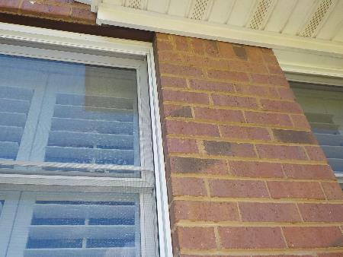 | #2 | 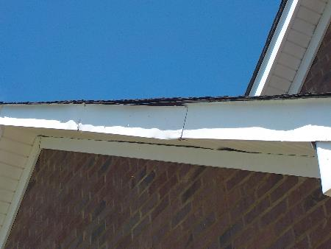
 | Windows bordering brick siding should have been caulked between the frame and brick, which prevents moisture/air intrusion. |  | Left of garage doors, fascia covering has dents, slight separation.
#3 | 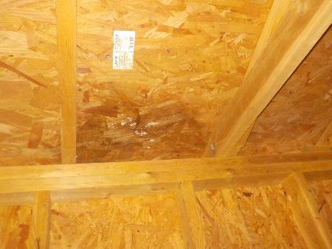 | #4 | 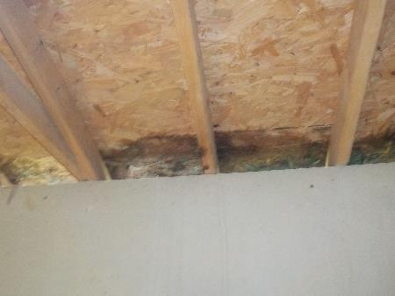
 | Rear shed on block - roof decking along eaves have water damage & mold growth. |  | Rear shed on block - roof decking along eaves have water damage & mold growth.
#5 | 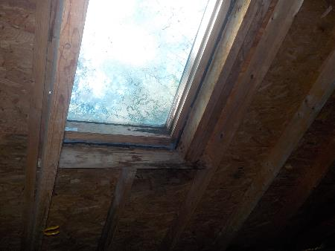 | #6 | 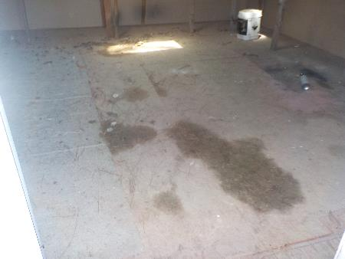
 | Rear shed on block, skylights have evidence of water intrusion. |  | Rear shed on block - back room flooring has significant deflection/damage.

PHOTOGRAPHS
#7 |  | #8 | 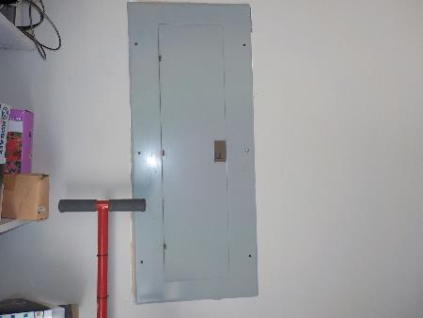
 |  |  | Cover to the electric panel box in garage is only secured with one screw.
#9 | 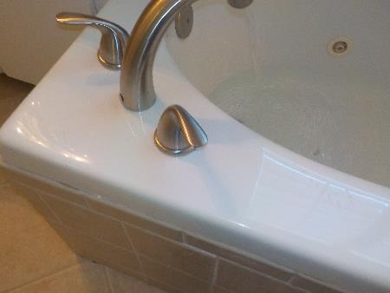 | #10 | 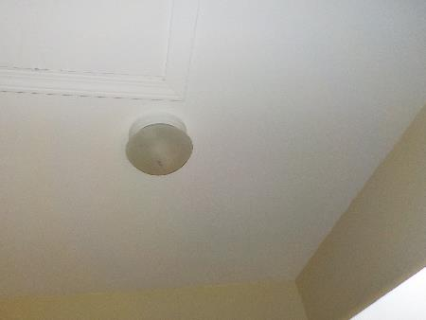
 | Master bath whirlpool tun hot water valve fixture is slightly loose. |  | In master bath closet, ceiling appears to have dried staining around light fixture. No correlation from inside attic scuttle.
#11 | 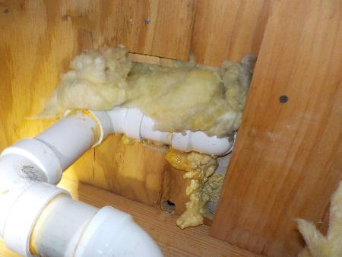 | #12 | 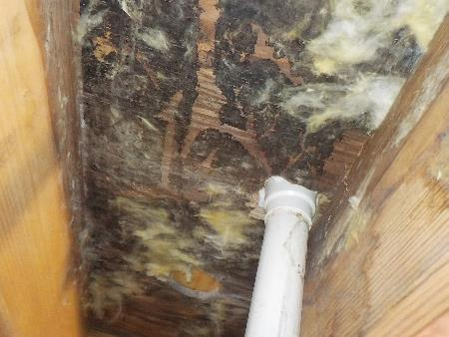
 | Inside crawl space under the master bath, leak at drain pipe joint of whirlpool tub. Sub-flooring under master bath has water staining, surface mold, and areas of wood fungus. Further evaluate, repair/correct as necessary by a licensed plumber or general contractor. |  | Inside crawl space under the master bath, leak at drain pipe joint of whirlpool tub. Sub-flooring under master bath has water staining, surface mold, and areas of wood fungus. Further evaluate, repair/correct as necessary by a licensed plumber or general contractor.

PHOTOGRAPHS
#13 | 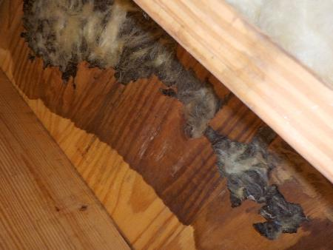 | #14 | 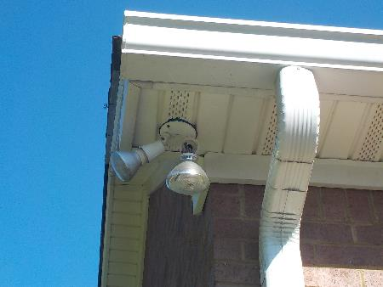
 | Inside crawl space under the master bath, leak at drain pipe joint of whirlpool tub. Sub-flooring under master bath has water staining, surface mold, and areas of wood fungus. Further evaluate, repair/correct as necessary by a licensed plumber or general contractor. |  | One rear exterior flood light is damaged; hanging by wire.
#15 | 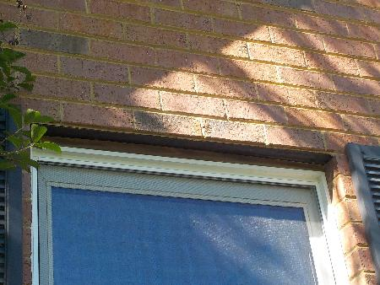 | #16
 | The front two garage windows have gaps along the top hat have been covered with wood trim. The wood trim has water/moisture absorption and should be replaced. The gap should be covered with cladding, vinyl, or masonry.
#17 |  | #18

PHOTOGRAPHS
#19 |  | #20
#21 |  | #22
#23 |  | #24

PHOTOGRAPHS
#25 |  | #26
#27 |  | #28
#29 |  | #30

